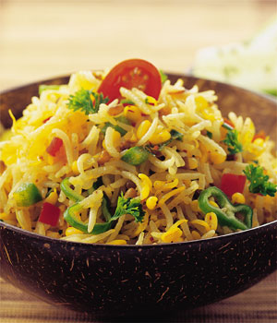

* **Vegetable Pulao**
* **Basmati rice — 1 1/2 cups**
* **Oil or ghee — 2 tablespoons**
* **Cinnamon stick — 1**
* **Cardamom pods — 4-5**
* **Peppercorns — 4-6**
* **Whole cloves — 3-4**
* **Onion thinly sliced — 1**
* **Water or stock — 3 cups**
* **Salt and pepper — to taste**

**Method:**

1. **Place the rice in a large bowl and rinse in 3-4 changes of water until the water runs fairly clear.**
2. **Fill the bowl with water to cover the rice by 1 inch and let soak for 20-60 minutes.**
3. **Drain well and set aside. Heat the oil or ghee in a large saucepan over medium heat.**
4. **Add the whole spices and stir until fragrant, about 20-30 seconds. Do not burn.**
5. **Stir in the onion and sauté until translucent. Add the drained rice and stir until heated through and all the grains are coated with the oil or butter. Stir in the stock or water and bring to a boil.**
6. **Reduce heat to lowest setting, cover tightly and simmer for 15 minutes. Remove from heat and let rest, covered, another 5-10 minutes. Remove lid, fluff rice with a fork and serve.**